BEREA TOURISM COMMISSION MINUTES
BUSINESS MEETING
WEDNESDAY, October 12, 2022, 3:00 PM

City Annex Building
304 Chestnut Street

Called to order at 3:04 PM; Patrick Huston presiding.

COMMISION MEMBERS PRESENT:
- Kristy Napier
- Becky Brown
- Laura Carpenter
- Bill West
- Patrick Huston

SUPPORT STAFF PRESENT:
- Donna Angel
- Nancy Conley
- Dani Gift

GUESTS PRESENT:
- City Administrator Rose Beverly
- Mayor Bruce Fraley
- Amanda Olmstead – Right Place Media
- Jay Nolan – Kentucky Sign Center
- Richard Olson – Berea Urban Farm
- Cheyenne Olson – Berea Urban Farm

APPROVAL OF Agenda:
Kristy Napier moved to approve the agenda. Second by Laura Carpenter. Motion passed unanimously.

APPROVAL OF MINUTES – May 11, 2022:
Laura Carpenter moved to approve minutes. Second by Kristy Napier. Motion passed unanimously.

PUBLIC COMMENTS:
None.

Sustainable Berea
Richard Olson, from Sustainable Berea, presented on the Urban Farm’s role in agricultural tourism and how they market it through the use of Ag Mag, their 32-page bi-annual magazine. Olson requested $2,500 from Berea Tourism in matched marketing funds to support this publication. Bill West motioned to approve the $2,500 matching funds. Second by Laura Carpenter. Motion passed unanimously.

Right Place Media
Amanda Olmstead, accounts manager from right place media, presented on the current status of Berea Tourism’s digital marketing campaigns. Olmstead presented information based on Kentucky Tourism research that identified shopping and local foods as the top two activities people participated in on overnight trips in Kentucky. This research also identified internet searches and social media as the top two actions taken to obtain information about traveling to Kentucky. Olmstead also introduced an influenced location visit report, which will be tracking devices that visit Berea after a Berea ad has been shown. This data will be made available at the end of the current campaign.

Within the current social media ads, the arts and crafts ads are performing better than the nature and food ads in Lexington, Cincinnati, and Knoxville.

All metrics for digital marketing are currently outperforming benchmarks.

Kentucky Sign Center
Jay Nolan from the Kentucky Sign Center presented on his quote for a digital sign at the Chestnut Street Pavilion. Three options ranging in size, brightness, and clarity were explained, along with estimated costs.

DIRECTOR’S REPORT: Donna Angel
BUSINESS TOPICS:

- New wrap for the Tolle Building
- Lexington Airport: Welcome to the Bluegrass
- Article Highlights: Great Escapes
- Christmas Theme: It’s a Candy Cane Kind of Christmas
- Shop Small Saturday: 11/26/2022
- Merry Mingling Event: 11/26/2022, 6-7:30pm
- MCIC Visit – November 7-8-9
- Meeting Date change request from November 9 to November 16.Vote to change the meeting date was unanimous.

OPERATIONS MANAGER REPORT: Nancy Conley

- KY Visitor Guide Leads:
January thru September 27, 2022: 1,440 leads received

Top 10 states are the same as last month just in a different order:

Kentucky | 198
Ohio | 113
Illinois | 80
Michigan | 75
Florida | 74
Indiana | 69
Pennsylvania | 68
Wisconsin | 68
Texas | 62
Missouri | 47

- New Part Time Receptionists: Charlena Wirth and Ted Kinson
- Continue with Staff Familiarization Tours
- Gearing up for fall events and winter holiday season
- Fall decorations set up in Old Town Artisan Village
- Adopt a Fire Hydrant: fun team building activity
- Halloween at the Park: will set up and participate in this event
- Madison County Youth Leadership: Junior Student group visited Berea including the Old Town Artisan Village for Arts Across the Curiculum (AKA Discover the Arts)

Facebook | July 2022 | August 2022 | September 2022
Total Posts | 102 | 101 | 111
Total Reach | 272,398 | 60,928 | 429,470
Engagement | 7,034 | 5195 | 5,151
Link Clicks | 11,122 | 525 | 1,087
Followers | 11,076 | 11,224 | 11,532
Instagram | July 2022 | August 2022 | September 2022
Total Posts | 87 | 94 | 105
Total Impressions | 35,034 | 25,346 | 51,711
Account Reached | 7397 | 3,690 | 9,813
Website Taps | 41 | 35 | 49
Followers | 3,532 | 3,564 | 3,615
Constant Contact | July 2022 | August 2022 | September 2022
Open Rate | 48% | 42% | 48%
Click Rate | 7% | 4% | 14%
New Subscribers | 231 | 175 | 375
Total Subscriptions | 13,413 | 13,622 | 13,997
Media Report – Dani Gift

Digital Media Projects (Completed)
- Website updates (Informational: Merchant addresses, hours, photos, etc.)
Digital Media Project (Ongoing)
- Social media marketing campaign for Make it, Take it, Give it LearnShops
- Berea Biz & The Monthly Tourism Newsletter
- Website updates (Look and Feel of History and Public Art Sections)
- Created the “My Town Monday” Facebook/Instagram series
- Events/ Calendar Updates
- Implementing Facebook Stories
Print Projects (Completed)
- Spoonbread Ad in the Berea Citizen
- Mitchell Tolle Sign Design
- Flyers for fire hydrant painting, Boone Way Yard Sale, & Tree Week
Print Projects (Ongoing)
- Map of all shopping, dining, and lodging locations
- Banners and Flyers for Christmas

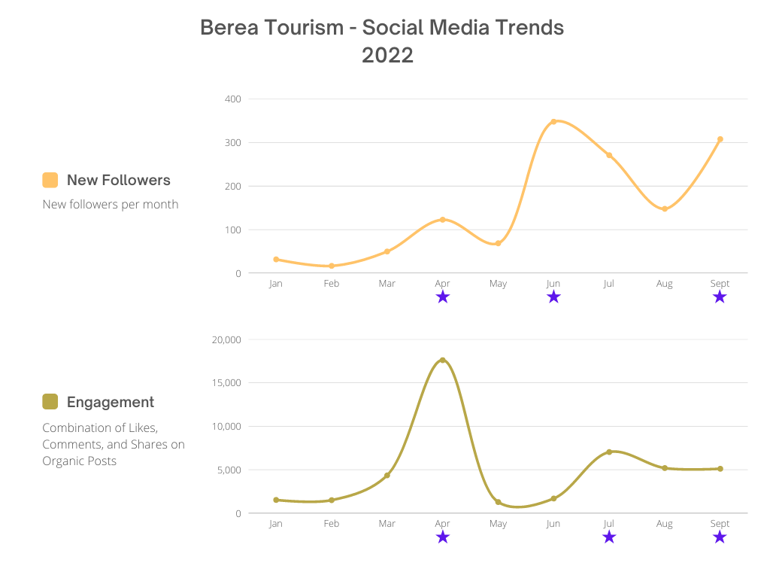

Motorcoach Report – Ethan Cima:
Ethan Cima’s motorcoach report was presented by Patrick Huston, and included detailed accounts of the 9 scheduled busses.

Bus Report:
September 1st, 2022 – Go Croswell Tours came to Berea from Williamsburg, OH. This was a combined group of 3 buses that came together for entertainment while in Berea. I helped to assist this group by lining up their entertainment for them at Boone Tavern during their lunch.
September 4th, 2022 – Collette Tours came to Artisan Village arriving at 9:30 AM for live demonstrations from our working artists in Old Town. The group size was 28 and consisted of travelers from all over the United States. After watching the artists demonstrate, the group had time afterwards to shop and visit before heading to lunch at Boone Tavern.
September 4th, 2022 – Southern Escape Tours out of Nashville, TN came to Berea to stop and eat dinner. I helped to arrange their dinner at Boone Tavern, while also providing options for entertainment groups during the dinner.
September 14th, 2022 – YMT Tours stopped in Artisan Village to shop and meet with the artists while here. This group had 28 people traveling. This was YMT’s first stop in Berea for group travel, we are looking to make strides in gaining more tours from this company in 2023.
September 23rd, 2022 – Get up ‘n’ Go Tours traveled to Berea for a 3-day trip. They were from Vienna, WV and loved visiting our town. I assisted with setting up their entertainment for two meals at Boone Tavern. On the 23rd, I provided a tour of Berea with the group, explaining the history of our town and what we offer present day as well. This group was 16 people, who were staying at the Holiday Inn while in Berea for 2 nights and 3 days.
September 24th, 2022 – Sunshine Tours stayed in Berea for 3 days and 2 nights as well. This group stayed at the Fairfield Inn while visiting. I helped to assist this group with entertainment options for two meals at Boone Tavern and then on the 24th I met with the group and provided a tour of the town, this group had 39 people traveling.
September 24th, 2022 – Fantasy RV Tours out of Las Vegas, NV came to visit Berea. I provided a step-on tour of the town starting at the Kentucky Artisan Center and ended at Artisan Village. The group size was 50 passengers, when arriving to Artisan Village they then were given the opportunity to shop from 11:00-12:30 before heading to the Dinner Bell for lunch.
September 25th, 2022 – Collette Demos came to Artisan Village at 9:30 am to watch our demonstrating artists throughout Old Town. The group consisted of 25 travelers, who had the chance to shop and meet with artists after demos. They left from Old Town to Boone Tavern, where they had lunch.
September 26th, 2022 – Gate1 Travel stopped in Berea on their tour coming from Louisville, KY. This group had 27 passengers, who had the opportunity to watch our artists demonstrate their craft. After their demos, the group had time to shop and enjoy Old Town on their own. Gate1 is a company that we are looking to develop more of a relationship with in 2023, they loved Berea and Old Town. A few said they wanted to move here.
Upcoming:
October is a busy month for buses in Berea, we are looking as of right now, 10 buses coming into town just in a few short weeks. As of today, we have had 4 buses already travel into Berea for the month of October. I expect this number to increase, due to how popular the Fall season is.
I have been working on my profile sheet for the fast-approaching conferences. After going through multiple trial and errors, I think me, and Donna have decided on the perfect option. This profile sheet will be able to provide many options to all types of tour groups. It also is able to capture and showcase all sides of Berea that we have to offer.
Scheduling of Appointments have opened for the ABA conference next year in Detroit, MI. I am in the process of getting our profile updated with the latest information and graphics that are able to tell tour companies what Berea has to offer. It will not be until January of next year that the appointments will be confirmed and have a specific time and date.
Other:
During September, I attended the Guest Relations Associations conference. This conference travels around the US year after year, but for 2022 it was in Berea. I can say that I learned more about what our town has to offer and what excitement that brings me being able to gain knowledge that will help me in my role at Berea Tourism. We had the opportunity to hear from Cheryl Hargrove, our guest speaker who talked about tourism as a whole. It was exciting to hear because it mostly involved group travel and the “ins and outs” of how that industry works. GRA is a group that many multi-million-dollar companies are members of, of who I had the chance to meet and learn from. Among these were, Ben and Jerry’s Ice Cream, Heaven Hill Distillery, Jelly Belly, and various others. A truly knowledgeable event that I felt when I walked away with more insight on how to continue to raise the bar in my position at Berea Tourism.

COMMISSIONER COMMENTS:

None

ADJOURNMENT:
Kristy Napier moved to adjourn. Laura Carpenter second. Motion passed unanimously. Meeting adjourned at 4:26 PM.

